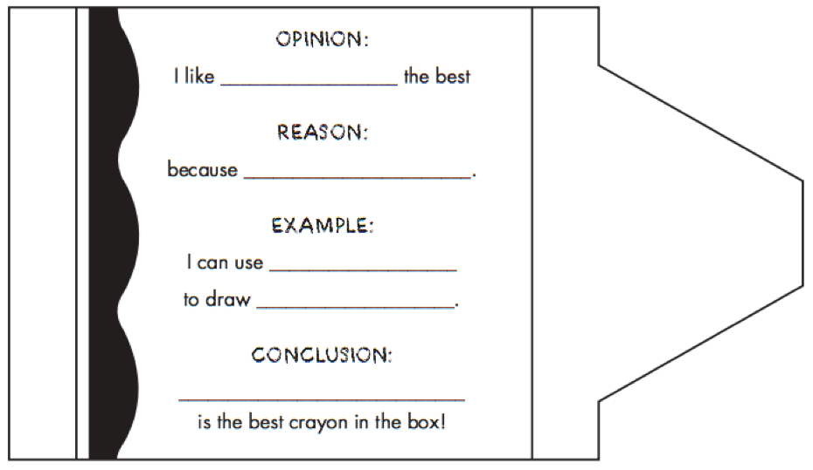

Directions:

1. Add your NAME to back of crayon
2. Fill-in the blanks
3. Color the top & bottom of crayon (NOT where the writing is)
4. Cut out crayon
5. Hang crayon up